CaXchange-ESB Clustering

Test Plan

Document Change History
Version Number | Date | Contributor | Description
1.0 | December 2007 | Yogaraj Khanal | Initial Draft


Updated Dec 9, 2007

Table of Contents

1 Introduction 4
1.1 Scope 4
1.1.1 In Scope 4
1.1.2 Out of Scope 4
1.2 Quality Objective 5
1.2.1 Primary Objective 5
1.2.2 Secondary Objective 5
1.3 Roles and Responsibilities 5
1.3.1 Developer 5
1.3.2 QA 5
1.4 Assumptions for Test Execution 6
1.5 Constraints for Test Execution 6
1.6 Definitions 6
2 Test Methodology 7
2.1 Purpose 7
2.1.1 Overview 7
2.1.2 Usability Testing 7
2.1.3 Unit Testing (Multiple) 7
2.1.4 Iteration/Regression Testing 7
2.1.5 Final release Testing 8
2.1.6 Testing completeness Criteria 8
2.2 Test Levels 8
2.2.1 Build Tests 8
Level 1 - Build Acceptance Tests 8
Level 2 - Smoke Tests 8
Level 2a - Bug Regression Testing 8
2.2.2 Milestone Tests 8
Level 3 - Critical Path Tests 8
2.2.3 Release Tests 9
Level 4 - Standard Tests 9
2.3 Bug Regression 9
2.4 Bug Triage 9
2.5 Suspension Criteria and Resumption Requirements 9
2.6 Test Completeness 9
2.6.1 Standard Conditions: 9
2.6.2 Bug Reporting & Triage Conditions: 10
3 Test Deliverables 10
3.1 Test Approach 11
3.2 Test Cases 11
3.2.1 Test Cases and Requirement Traceability 11
3.2.2 Test Case Description 12
Test Case 1: Count the number of machines clustered 12
Test Case 2: Add the number of machines in the cluster 12
Test Case 3: Delete the number of machines in the cluster 12
Test Case 4: View the message queue for the each JBI endpoint 12
Test Case 5: Bring down the one of the machine in clustered environment and run the application 12
Test Case 6: Change jms flow to other types of flow like SEDA,JCA and ST and see if the clustering works 12
Test Case 7: Add servicemix instances in the cluster 13
Test Case 8: Message exchanges processing time before clustering 13
Test Case 9: Message exchanges processing time after clustering 13
3.3 Defect Tracking & Debugging 13
3.3.1 Testing Work flow 13
3.3.2 Defect reporting using GFORGE 14
3.4 Reports 15
3.4.1 Testing status reports 16
3.4.2 Test Final Report - Sign-Off 16
3.5 Responsibility Matrix 16
4 Resource & Environment Needs 16
4.1 Testing Tools 16
4.1.1 Tracking Tools 16
4.2 Test Environment 17
4.2.1 Hardware 17
4.2.2 Software 17
4.3 Bug Severity and Priority Definition 17
4.3.1 Severity List 18
4.3.2 Priority List 18
4.4 Bug Reporting 18
5 Terms/Acronyms 19

Introduction
The caXchange is defined as the software component that is primarily responsible for receiving input from various external systems, routing the input to various services that are hosted on the hub, and eventually routing the output of those services to external systems.

Servicemix supports clustering of containers. Clustering in servicemix provides load balancing of messages across servers and machines, high availability(HA) of services and fault tolerance(if machine crashes, messages are automatically delivered to another machine),durability(persist message to disk and database ) to ensure they survive catastrophic hardware failure, local JMS transactions or full XA transaction support.

This documentation describes the test plans for clustering functionality caXchange provides. Its scope is limited to test plans for capturing clustering information from caXchange. Component deployment happens in the same way as a normal Servicemix JBI container (both for the POJO and archive Component deployment).

ActiveMQ is the most popular and powerful open source message broker and enterprise integration pattern provider that is used for clustering of servicemix containers. We are implementing master slave clustering approach for the serviceix. The idea behind master slave is that messages are replicated to a slave broker so that even if you catastrophic hardware failure of the master’s machine, file system or data center, you get immediate failover to the slave with no message loss. Also the master slave is the recommended way of providing high availability and fault tolerance for Apache ActiveMQ. Also there is no central point of failure in this approach.

Scope

In Scope
The test scope for caXchange-ESB Clustering includes the following:
- Quality requirements and fit metrics of ESB Clustering
- End-to-end testing and testing of interfaces of all systems that interact with the caXchange ESB Clustering
- Performance test for ESB Clustering
- Usability Testing for ESB Clustering

Out of Scope
The following areas for ESB Clustering are Out of Scope:
- Functional requirements testing for systems outside caXchange ESB Clustering
- Testing of Business SOPs, disaster recovery and Business Continuity Plan.

Quality Objective

Primary Objective
A primary objective of testing application systems is to: assure that the system meets the system requirements, including quality requirements (AKA: Non-functional requirements), fit metrics for each quality requirement, satisfies the use case scenarios and maintains the quality of the product. At the end of the project development cycle, the user should find that the project has met or exceeded all expectations as documented in the requirements.

Any changes, additions, or deletions to the requirements document, Functional Specification, or Design Specification will be documented and tested at the highest level of quality allowed within the remaining time of the project and within the ability of the test team.

Secondary Objective
The secondary objective of testing application systems will be to: identify and expose all issues and associated risks, communicate all known issues to the project team, and ensure that all issues are addressed in an appropriate manner before release. This requires careful and methodical testing of the application to first ensure all areas of the system are scrutinized and, consequently, all issues (bugs) found are dealt with appropriately.

Roles and Responsibilities

Developer
An NCI-designated Cancer Center selected and funded by NCICB to participate in a specific Workspace to undertake software or solution development activities. Responsible to:
(a) Develop the system/application
(b) Develop Use cases and requirements
(c) Conduct Unit, system, regression and integration testing
(d) Support user acceptance testing

QA
An NCI-designated Cancer Center selected and funded by NCICB to undertake formal testing, and validation of application products or solutions developed by Workspace Developers. Responsible to:
(a) Contribute to Use case, requirement development through review
(b) Contribute to development and execution of the unit test scripts through review
(c) Conduct Full User Acceptance, regression, and end-to-end testing; this includes identifying test scenarios, building the test scripts, executing scripts and reporting test results

Assumptions for Test Execution

The caXchange– ESB Clustering testing effort has inherent dependencies on the existing NCICB products involved in the architecture and other factors such as business, software, or personnel aspects. These dependencies are documented as assumptions in this section.
- For User Acceptance testing, the Developer team has completed unit, system and integration testing and met all Requirement’s (including quality requirements).
- Test results will be reported on daily basis using GForge. Failed scripts and defect list from GForge with evidence will be sent to the Developer directly.
- Use cases have been developed for Acceptance testing. Use cases are approved by test lead.
- Test scripts are developed and approved.
- Web SSO – caGrid Authentication and Authorization: User authentication will be performed by appropriate application (C3PR, caAERS, PSC etc.). User’s grid credential will be used to connect to the caXchange (via Grid node). The user authorization will be performed by Grid Delegation Service by using grid identity passed to the caXchange as part of the user request.
- CLM – for auditing and logging of the actions in the caXchange.
- No data conversion or translation other than format conversion will be performed in caXchange

Constraints for Test Execution

- Developer will receive consolidated list of request for test environment set up, user accounts set up, data set (actual and mock data), defect list, etc. through GForge after the initial Adopter testing kick off meeting.
- Developer will support ongoing testing activities based on priorities

Definitions
Bugs: A defect is a problem with the software, where the application or system component is not working as designed, causes unexpected behaviors, or is not functioning in accordance with the requirements.

Feature Request:
A feature request is a request to add functionality or enhance current functionality from what was designed and coded.

Features can be added as a new requirement going through the appropriate Change Management process.

Test Methodology

Purpose

Overview

The purpose of the Test Plan is to achieve the following:
- Define testing strategies for each area and sub-area to include all the functional and quality (non-functional) requirements.
- Divide Design Spec into testable areas and sub-areas. Be sure to also identify and include areas that are to be omitted (not tested) also.
- Define bug-tracking procedures.
- Identify testing risks.
- Identify required resources and related information.
- Provide testing Schedule.

Usability Testing
Usability testing will not be conducted on the caXchange-ESB Clustering v1.0 due to time constraints.

Unit Testing (Multiple)
Unit Testing is conducted by the Developer during code development process to ensure that proper functionality and code coverage have been achieved by each developer both during coding and in preparation for acceptance into iterations testing.

Iteration/Regression Testing
At each iteration, a debriefing should be held. Specifically, the report must show that to the best degree achievable during the iteration testing phase, all identified priority 1 and 2 bugs have been communicated and addressed. At a minimum, all priority 1 and priority 2 bugs should be resolved prior to entering the beta phase.

Important deliverables required for acceptance into Final Release testing include:
- Application set up
- Installation instructions
- All documentation (beta test scripts, manuals or training guides, etc.)

Final release Testing
Assuming critical bugs are resolved during previous iteration test cycles - Throughout the Final Release test cycle, bug fixes will be focused on minor and trivial bugs (priority 3 and 4). Testing will continue its process of verifying the stability of the application through regression testing (existing known bugs, as well as existing test cases).

The milestone target of this phase is to establish that the application under test has reached a level of stability, appropriate for its usage (number users, etc.), that it can be released to the end users and caBIG community.

Testing completeness Criteria
The milestone target is to place the release/app (build) into production after it has been shown that the app has reached a level of stability that meets or exceeds the client expectations as defined in the Requirements, Functional Spec., and caBIG Production Standards.

Test Levels
The test categories and test levels are defined below:

Build Tests

Level 1 - Build Acceptance Tests
System will be checked to see if the proper Development Release Document plus other build related information (drop point, etc.) is in place. The objective is to determine if further testing is possible. If any Level 1 test case fails, the build is returned to developers untested.

Level 2 - Smoke Tests
The objective is to determine if further testing is possible. These test cases will emphasize breadth more than depth. All components will be touched, and every major feature should be tested briefly by the Smoke Test. If any Level 2 test case fails, the build is returned to developers untested.

Level 2a - Bug Regression Testing
Every bug that was “Open” during the previous build, but marked as “Resolved,” needs re-testing. The current build under test will need to be regression tested as well. Once the smoke test is completed regression testing can commence.

Milestone Tests

Level 3 - Critical Path Tests
Critical Path test cases must pass by the end of every 2-3 Build Test Cycles. They will not need to be tested every drop, but must be tested at least once per milestone. Thus, the Critical Path test cases must all be executed at least once during the Iteration cycle, and once during the Final Release cycle.

Release Tests

Level 4 - Standard Tests
Functional test cases may be executed multiple times with each Iteration, as they could be flagged to be included in the regression test suite after their initial execution.
Standard test cases usually include Installation, Data, GUI, and other test areas.

Bug Regression
All bugs that are resolved as “Fixed, Needs Re-Testing” will be regressed when Testing team is notified of the new drop containing the fixes. When a bug passes regression it will be considered “Closed, Fixed”. If a bug fails regression, the testing team will notify development team by entering notes into GForge. When a high severity bug fails regression, the Testing team should also put out an immediate email to development. The Test Lead will be responsible for tracking and reporting to development and product management the status of regression testing.

Bug Triage

The Test Lead, Product Manager, and Development Lead should all be involved in these triage meetings. The Test Lead will provide required documentation and reports on bugs for all attendees. The purpose of the triage is to determine the type of resolution for each bug and to prioritize and determine a schedule for all “To Be Fixed Bugs’. Development will then assign the bugs to the appropriate person for fixing and report the resolution of each bug back into the GForge bug tracker system. The Test Lead will be responsible for tracking and reporting on the status of all bug resolutions.

Suspension Criteria and Resumption Requirements
A bug report should be filed by the development team. After fixing the bug, the development team will follow the drop criteria (described above) to provide its latest drop for additional testing. At that time, the testing team will regress the bug, and if passes, continue testing the module.

Test Completeness
Testing will be considered complete when the following conditions have been met:

Standard Conditions:
- When testing team and Developers, agree that testing is complete, the app is stable, and agree that the application meets functional requirements.
- Script execution of all test cases in all areas have passed.
- Automated test cases have in all areas have passed.
- NCI approves the test completion
- Each test area has been signed off as completed by the Test Lead.
- No ‘Critical or High’ Priority bugs that have no definable workaround remain

Bug Reporting & Triage Conditions:
- Bug find rate indicates a decreasing trend prior to Zero Bug Rate (no new priority. 1/2 bugs found).
- Bug priority distribution has changed to a steady decrease in Priority. 1 and 2 bugs discovered.
- No ‘Critial or High’ bugs that have no definable workaround remain.

Test Deliverables
Testing will provide specific deliverables during the project. These deliverables fall into three basic categories: Documents, Test Cases / Bug Write-ups, and Reports. Here is a diagram indicating the dependencies of the various deliverables:

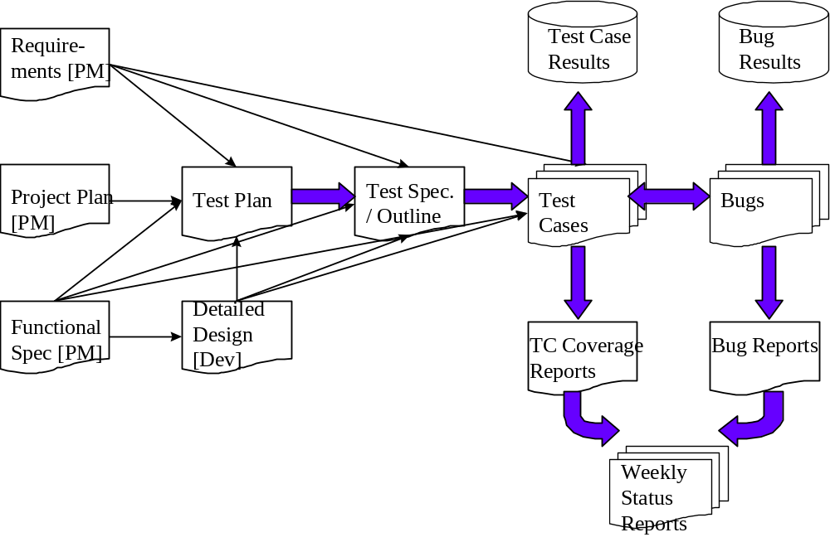

As the diagram above shows, there is a progression from one deliverable to the next. Each deliverable has its own dependencies, without which it is not possible to fully complete the deliverable.

The following page contains a matrix depicting all of the deliverables that Testing will use.

Test Approach
A JMS Flow is used for cases where we need collaboration between more than one Servicemix JBI Container(for fail over or scalability).Component deployment happens in the same way as normal Servicemix JBIContainer (both for POJO and archive Component deployment) but all the components in the cluster are notified of a deployment, and the JMS flow will handle automatic routing ( and fail over) of Message Exchanges between the container instances. A message queue is used for each JBI endpoint, so multiple instances of the same named Component will have request load balanced across them.

Test Cases

Test Cases and Requirement Traceability
Here are some of the test cases that will be tested for the caXchange ESB Clustering. The test cases are sequential in the order of dependency.

Test Case No | Requirement Id | Features to be tested | Test Cases
1 | 1.0 | Count the number of servicemix containers clustered | View the number of machines configured inside conf/activemq.xml and conf/servicemix.xml
2 | 1.1 | Add the servicemix container in the cluster | Map the corresponding port of the cluster to conf/activemq.xml,conf/servicemix.xml and servicemix.properties file
3 | 1.2 | Delete the servicemix container in the cluster | Map the corresponding port of the cluster to conf/activemq.xml,conf/servicemix.xml and servicemix.properties file
4 | 2.0 | View the message queue for the each JBI endpoint using JMX console | Multiple instances of the same component will have request load balanced across them
5 | 3.0 | Bring down the one of the machine in clustered environment and run the application | Test to see if the application runs normally
6 | 4.0 | Change jms flow to other types of flow like SEDA,JCA and ST and see if the clustering works | Check to see if other type of flow supports clustering
7 | 5.0 | Add servicemix instances in the cluster | Add unique name to the conf/servicemix.xml
8 | 6.0 | Message exchanges processing time before clustering | Time to process message exchanges before clustering
9 | 7.0 | Message exchanges processing time after clustering | Time to process message exchanges after clustering
10 | 8.0 | View the jms console to see if jms flow is enable | This test case ensures that jms flow is enabled for the clustering
11 | 9.0 | View the jmx console to see the no of ActiveMQ and servicemix instances | It verifies the number of serivcemix and activemq instances running in the cluster
12 | 10.0 | View jmx console to see the number of containers configured in the cluster | Give graphical way of viewing the containers in the cluster
13 | 11.0 | See if there is corresponding endpoint created in ActiveMQ instance for the corresponding serivcemix instances | To verify that serivcemix and activemq shares the common JBI endpoint
14 | 12.0 | View to serivcemix properties file to check if the instances of serivcemix and activemq are listening on the different port | To verify that each of the instance have separate rmi port
15 | 13.0 | Change the activemq port that servicemix is configured to and run the cluster and check if still works | This is for the verification of the configuration of the cluster
16 | 14.0 | Bring one of the cluster down when the application is processing message exchanges and verify that client gets the message exchange | To ensure that the cluster survives the fail over and ensures high availability
17 | 15.0 | Bring down the master broker and see if the slave process the requests | To ensure the slave handles failover
18 | 16.0 | Bring down the slave broker and see if the master process the requests | To ensure that master handles failover

Test Case Description

Test Case 1: Count the number of servicemix containers clustered
This test case will test the number of machine used for the clustering of the servicemix by looking as the corresponding configuration file. Servicemix uses embedded ActiveMQ internally to create the clustered environment. In this test case we will see how many machines are mapped in this file for the use of the clustered environment.

Test Case 2: Add the number of machines in the cluster
This test case will test the number of machine used for the clustering of the servicemix by looking as the corresponding configuration file. Servicemix uses embedded ActiveMQ internally to create the clustered environment. In this test case we will edit conf/activemq.xml to add additional machine in clustered environment.

Test Case 3: Delete the number of machines in the cluster
This test case will test the number of machine used for the clustering of the servicemix by looking as the corresponding configuration file. Servicemix uses embedded ActiveMQ internally to create the clustered environment. In this test case we will edit conf/activemq.xml to delete particular machine in clustered environment.

Test Case 4: View the message queue for the each JBI endpoint using JMX console
This test case will test the number of JBI endpoint used for the clustering of the servicemix by looking as the corresponding configuration queue. Servicemix uses embedded ActiveMQ broker with multi cast internally to create the clustered environment. In this test case we will use JMX console to view the queue for the each endpoint created.

Test Case 5: Bring down the one of the machine in clustered environment and run the application
This test case will test if the servicemix clustered container works the same way as if all the nodes were working. The prerequisite for running this test case will be that one of the machine should be configured incorrectly or it should be shut down to see that other machine will response in its absence.

Test Case 6: Change jms flow to other types of flow like SEDA,JCA and ST and see if the clustering works
Servicemix allows four different types of message dispatch policies within the Normalized Message Router(NMR) Broker. This test case verifies that jms flow ensures clustering with the embedded ActiveMQ Message Broker using multi cast. Also it verifies that other types of flow doesn't support clustering.

Test Case 7: Add servicemix instances in the cluster
This test case examines the new servicemix instance added to process the message exchanges. To add new servicemix instance we should add a unique name in the file conf/servicemix.xml.

Test Case 8: Message exchanges processing time before clustering
This test case calculates the estimates of the time required to processes the caXchange messages before clustering in the normal environment or with single node. This test case helps in load balancing for the application that we are designing.

Test Case 9: Message exchanges processing time after clustering
This test case calculates the estimates of the time required to processes the caXchange messages after clustering certain no of nodes in the cluster. This helps in the estimate of load balancing needed for our application.

Test Case 10: View the jms console to see if jms flow is enable
This test case checks of the jms flow is enabled for clustering. Servicemix relies is ActiveMQ for clustering. Jms flow is the one that handles clustering. So we can use JMX console to see the type of flow activated.

Test Case 11: View the jmx console to see the no of ActiveMQ and servicemix instances
This test case helps to see the no of ActiveMQ instances and serivcemix instances running in th e clustered environment. The idea is to enable and disable the different instances and check to see if they are running or not.

Test Case 12: View jmx console to see the number of containers configured in the cluster
This test case verifies the number of active serivcemix containers in the cluster. Also it allows us the graphical way of viewing the serivcemix containers with their respective JBI endpoint.
If we enable or disable the containers it should be reflected in jmx console after refreshing.

Test Case 13: See if there is corresponding endpoint created in ActiveMQ instance for the corresponding serivcemix instances
This test case verifies that if there are same endpoint created in Serivcemix for the endpoint in the ActiveMQ. The idea it to verify that both ActiveMQ and serivcemix instances should have same endpoint.

Test Case 14: View to serivcemix properties file to check if the instances of serivcemix and activemq are listening on the different port
This test case verifies that if the ActiveMQ is configured as external broker or not and if all the serivcemix containers are listening to it or not. The external broker configuration requires that each serivcemix containers listens to the same ActiveMQ port

Test Case 15: Change the activemq port that servicemix is configured to and run the cluster and check if still works
This test case verifies that the cluster doesn't work if the port no are configured in wrong way.
In this test case we knowing configure different port for each serivcemix containers that listens to activemq and see that cluster is not formed. This test case also verifies that if the embedded serivcemix is disabled or not.

Test Case 16: Bring one of the cluster down when the application is processing message exchanges and verify that client gets the message exchange
This test case checks that the serivcemix cluster survives the fail over of the serivcemix containers. The idea is to test that if one of the containers is down then other should process the message exchange requests.

Test Case 17: Bring down the master broker and see if the slave process the requests
This test case checks that there is no central failure point .Also it ensures the high availability and fault tolerance for Apache ActiveMQ. In this test case we will bring down the master broker that is handing message exchanges and sees if the pure master slave survives the failure. The expected result is that the slave broker should handle the message exchange if the master goes down until the master is back and running.

Test Case 18: Bring down the master broker and see if the master process the requests
This test case checks that there is no central failure point .Also it ensures the high availability and fault tolerance for Apache ActiveMQ. In this particular test case we will bring slave broker down form the master slave cluster and see if the cluster survives the failover. The expected result is that master broker functions normally if nothing has happened.

Defect Tracking & Debugging

Testing Work flow
The below work flow illustrates the testing work flow process for Developers and Adopters for User Acceptance and End to End testing.
Note the yellow highlighted process where the Adopter is required to directly send defect list with evidence to the Developer. Similarly, Developer is required to confirm directly with the Adopter after bug fixes along with updating on the GForge.
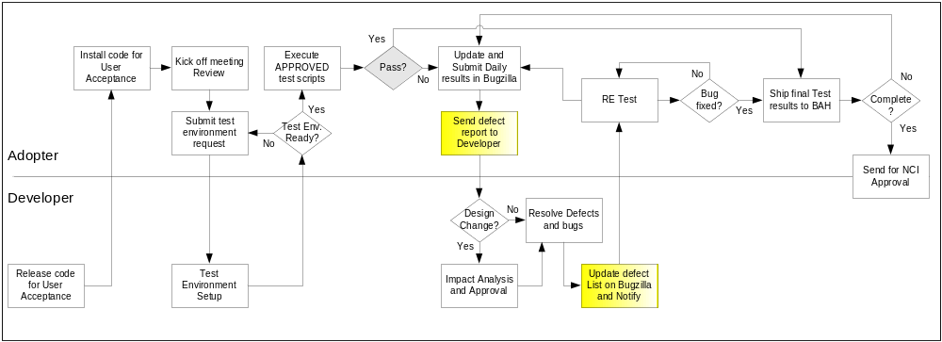

Defect reporting using GFORGE
ALL defects should be logged using ‘GFORGE’, to address and debug defects. Adopters are also requested to send a daily defect report to the developer. Developers will update the defect list on G Forge and notify the requester after the defect has been resolved.
Developers and Adopters are required to request an account on G Forge for the relative workspace. Debugging should be based on Priority – High > Medium > Low, these priorities are set by the Adopters and are based on how critical is the test script in terms of dependency and mainly based on use case scenario.
Below screen shot displays ‘Add new Defect’ screen, fields marked with ( * ) are mandatory fields and Adopters should also upload the evidence file for all the defects listed.

All High priority defects should be addressed within 1 day of the request and resolved/closed within 2 days of the initial request
All Medium priority defects should be addressed within 2 days of the request and resolved/closed within 4 days of the initial request
All Low priority defects should be resolved/closed no later than 5 days of the initial request.

G Forge URL - http://gforge.nci.nih.gov
User may either search for workspace or select from list of recent project from the bottom right side of the window. E.g. searching for ‘caTIES’.
At the workspace, the user can request Administrators to setup their user account for that workspace.
After login, user can select ‘Tracker’ tab to ‘Submit New’ defect. User can add defect info. As shown in below screen.

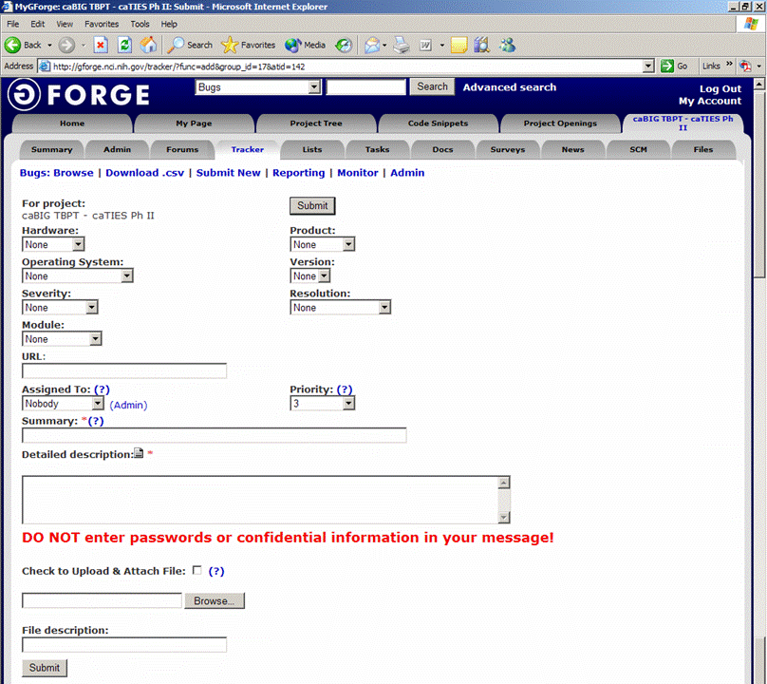
Field Comments
Hardware - List the testing environment hardware. e.g. PC, MAC
Product - Add default to workspace name e.g. caTIES
Operating System - Win 98, Win 2k, Win XP, MAC, etc.
Version - Application version
Severity - If it is an enhancement or a bug with minor to major severity that may not interfere with further testing or completely block any future testing efforts.
Resolution - Only DEVELOPER will update based on the defect
Module - For an application with multiple modules, select appropriate module for the defect reported.
URL - Add URL if any
Assigned to - To be updated by Developer, for whom the ticket is assigned to
Priority - Set a priority based on severity
Summary - Summary of the defect, bug or issue
Detailed Desc. - Details of the defect, bug or issue
Upload file - Attach evidence file
Submit - Submit the bug ticket

Reports
The Test Lead will be responsible for writing and disseminating the following reports to appropriate project personnel as required.

Testing status reports
A weekly or bi-weekly status report will be provided by the Test Lead to project personnel. This report will summarize weekly testing activities, issues, risks, bug counts, test case coverage, and other relevant metrics.

Test Final Report - Sign-Off
A Final Test Report will be issued by the Test Lead. It will certify as to the extent to which testing has actually completed (test case coverage report suggested), and an assessment of the product’s readiness for Release to Production.

Responsibility Matrix
These are the responsibilities of the resources assigned to caXchange ESB Clustering Test Plan.

Role | Name | Responsibility
Project Managers | Kalpesh Patel | Review and approve test materials
Developers | Amit Srivastava | Unit test, review and approve test materials
Testers | Yogaraj Khanal | Write and execute test plans, test cases and other test deliverables

Resource & Environment Needs

Testing Tools

Tracking Tools
GForge bug tracker is used by caBIG to enter and track all bugs and project issues. The Test Lead is responsible for maintaining the GForge database.

Test Environment

Hardware
The following is the hardware requirement for testing caXchange ESB clustering
- 2G Hard Disk Space
- 2G Ram
- Linux-compatible CPU

Operating System | Linux
Database | Oracle 9i
Browser | Firefox 2.x and Above  Internet Explorer 6 and above
Java | 1.5.x
Container | Servicemix 3.1.2 and Tomcat 5.0.28
Build Tools | Maven 2.0.7

Software
In addition to the application and any other customer specified software, the following list of software should be considered a minimum:

Software/Version:
==========================
Apache 2.2.4 Port 80
Tomcat 5.0.28-non secure
Boss 4.0.5(App server)
Postgres (database)
MySQL (database)
Globus 4.0.2 (embedded in tomcat)
ServiceMix 3.1.2(container)
Maven 2.0.7
Linux (OS)

Bug Severity and Priority Definition
Bug Severity and Priority fields are both very important for categorizing bugs and prioritizing if and when the bugs will be fixed. The bug Severity and Priority levels will be defined as outlined in the following tables below. Testing will assign a severity level to all bugs. The Test Lead will be responsible to see that a correct severity level is assigned to each bug.

The Test Lead, Development Lead and Program Manager will participate in bug review meetings to assign the priority of all currently active bugs. This meeting will be known as “Bug Triage Meetings”. The Test Lead is responsible for setting up these meetings on a routine basis to address the current set of new and existing but unresolved bugs.

Severity List
The tester entering a bug into GForge is also responsible for entering the bug Severity.

Severity ID | Severity Level | Severity Description
1 | Critical | The module/product crashes or the bug causes non-recoverable conditions. System crashes, GP Faults, or database or file corruption, or potential data loss, program hangs requiring reboot are all examples of a Severity. 1 bug.
2 | High | Major system component unusable due to failure or incorrect functionality. Severity. 2 bugs cause serious problems such as a lack of functionality, or insufficient or unclear error messages that can have a major impact to the user, prevents other areas of the app from being tested, etc. Severity. 2 bugs can have a work around, but the work around is inconvenient or difficult.
3 | Medium | Incorrect functionality of component or process. There is a simple work around for the bug if it is Severity. 3.
4 | Minor | Documentation errors or signed off severity 3 bugs.

Priority List
Priority ID | Priority Level | Priority Description
5 | Must Fix | This bug must be fixed immediately; the product cannot ship with this bug.
4 | Should Fix | These are important problems that should be fixed as soon as possible. It would be an embarrassment to the company if this bug shipped.
3 | Fix When Have Time | The problem should be fixed within the time available. If the bug does not delay shipping date, then fix it.
2 | Low Priority | It is not important (at this time) that these bugs be addressed. Fix these bugs after all other bugs have been fixed.
1 | Trivial | Enhancements/ Good to have features incorporated- just are out of the current scope.

Bug Reporting
Testing team recognizes that the bug reporting process is a critical communication tool within the testing process. Without effective communication of bug information and other issues, the development and release process will be negatively impacted.

The Test Lead will be responsible for managing the bug reporting process. Testing standard bug reporting tools and processes will be used. GForge is the company-wide standard Bug Logging / Tracking tool. Testing and development will enter their data into the GForge database following the field entry definitions defined below.

Terms/Acronyms

TERM/ACRONYM | DEFINITION
API | Application Program Interface
BAH | Booz Allen Hamilton
BCP | Business Continuity Plan
CAT | Client Acceptance Testing
End-to End Testing | Tests user scenarios and various path conditions by verifying that the system runs and performs tasks accurately with the same set of data from beginning to end, as intended.
ER;ES | Electronic Records; Electronic Signatures
N/A | Not Applicable
NCI | National Cancer Institute
QA | Quality Assurance
RTM | Requirements Traceability Matrix
SME | Subject Matter Expert
SOP | Standard Operating Procedure
TBPT | Tissue Bank and Pathology Tools
TBD | To Be Determined
TSR | Test Summary Report
CTODS | Clinical Trials Object Data System

